NSS Activity Report 2023-2024

The NSS unit of Lourdes Matha College of Science and Technology organized a Basic Life Support (BLS) Training session for its volunteers in association with the Fire Force Department. The training aimed to equip students with essential life-saving skills to handle emergency situations effectively. Experienced fire force personnel conducted the session, demonstrating techniques such as CPR (Cardiopulmonary Resuscitation), first aid for choking, bleeding control, and handling unconscious victims. Students actively participated in hands-on practice sessions, enhancing their confidence in responding to emergencies.
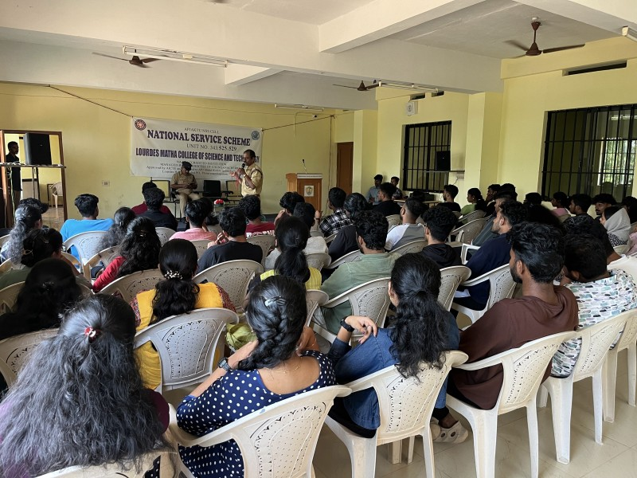

- Self-defense training session
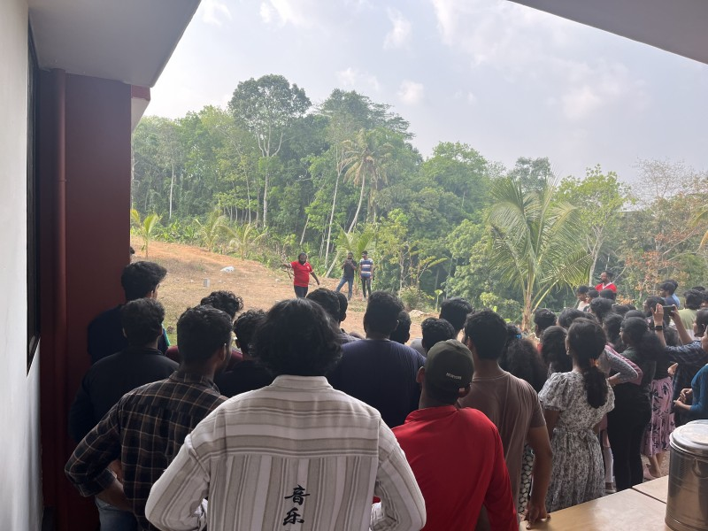
The NSS unit of organized a self-defence training session in collaboration with Kalari Sankham on [Date]. The session aimed to equip students, especially women, with essential self-defence techniques to enhance their safety and confidence.

- Blood Donation Camp
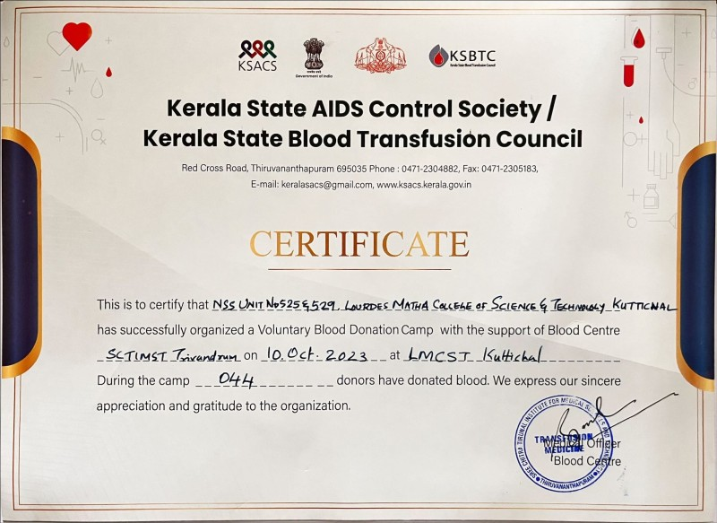
The NSS unit of Lourdes Matha College of Science and Technology organized a blood donation camp. The initiative was undertaken with the support of the Blood Centre, SCTIMST Trivandrum, to contribute to the noble cause of saving lives through voluntary blood donation.
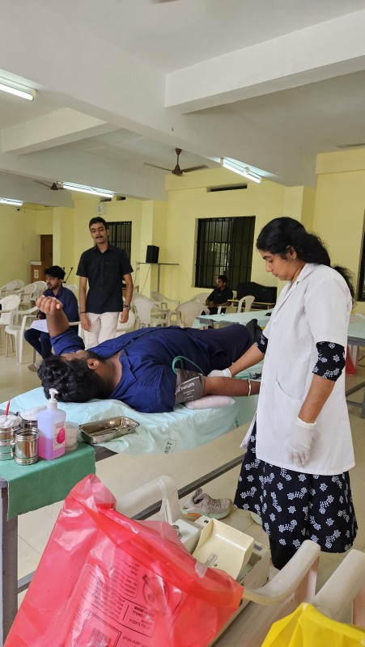

- NATPAC Survey
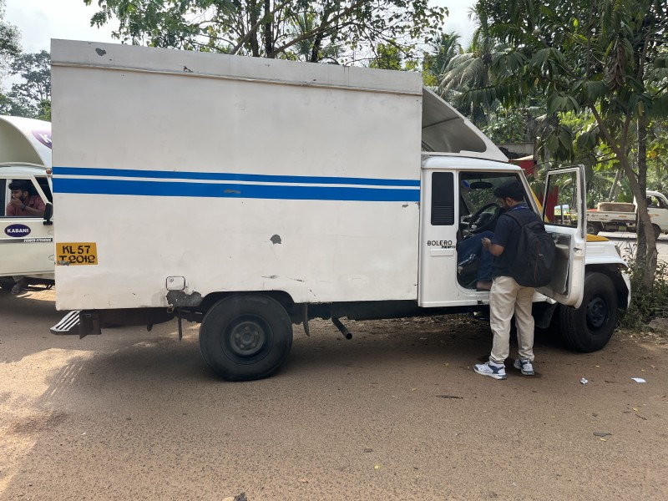
A survey to estimate the traffic volume of taxi and heavy vehicles for National Transportation planning and Research Centre(NATPAC) under the state government was conducted by NSS volunteers of Unit 343. NSS volunteers collected the information and data from the passengers.
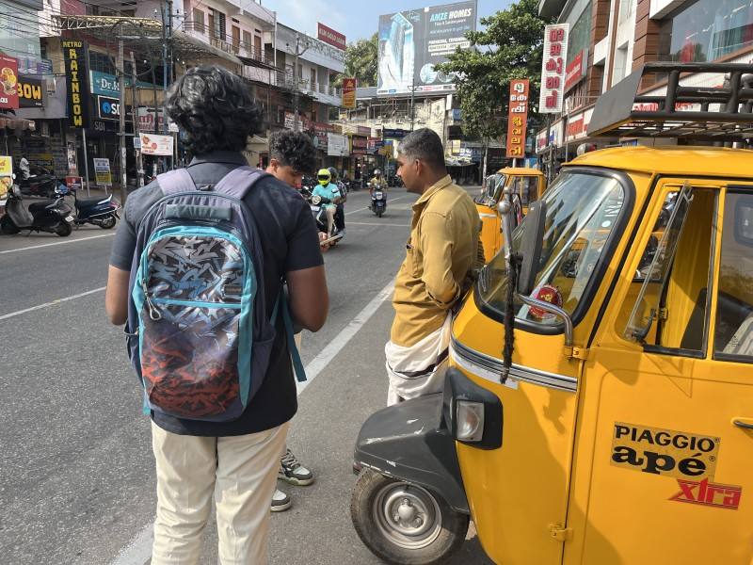

- SNEHARAMAM Project
As part of the SNEHARAMAM project, the NSS (National Service Scheme) unit of our college undertook a remarkable initiative to transform a waste dumping site in Kuttichal Panchayat into a beautiful and sustainable garden.
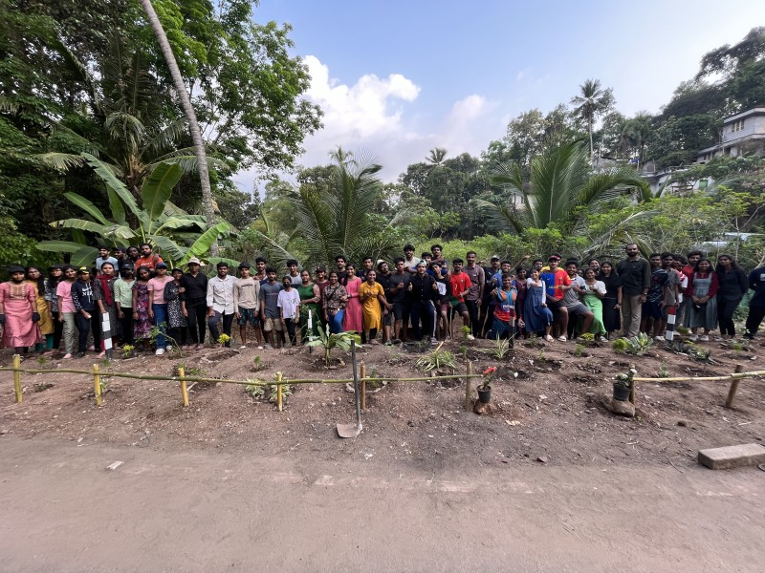
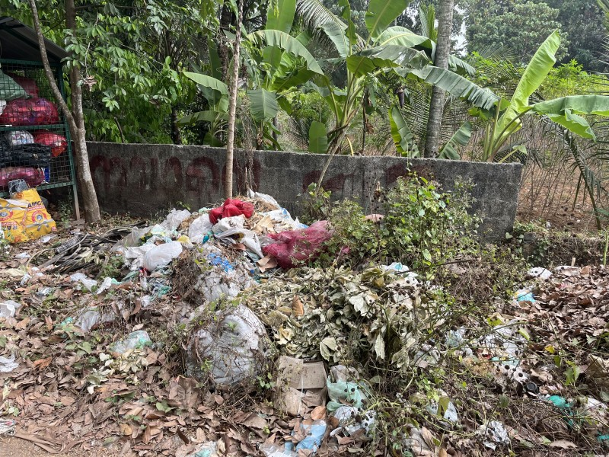
- Anti-Drugs Campaign
As part of Asaad Sena, NSS volunteers conducted an anti-drugs awareness campaign at Kuttichal Junction. The event aimed to educate the public, especially the youth, about the dangers of drug abuse and the importance of a drug-free society. Volunteers organized street plays, distributed pamphlets, and engaged in interactive sessions with the local community. Awareness messages were displayed on banners, and experts spoke about the harmful effects of substance abuse. The campaign received a positive response from the public, with many pledging to support the fight against drugs.
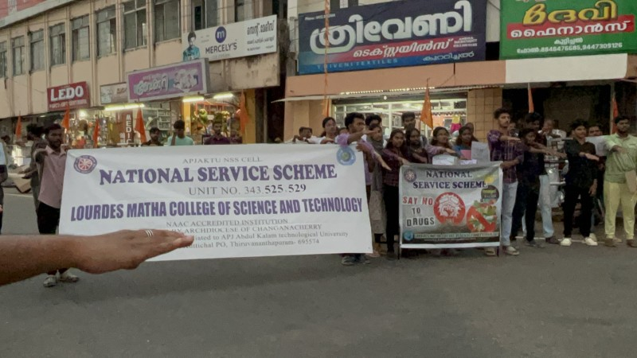
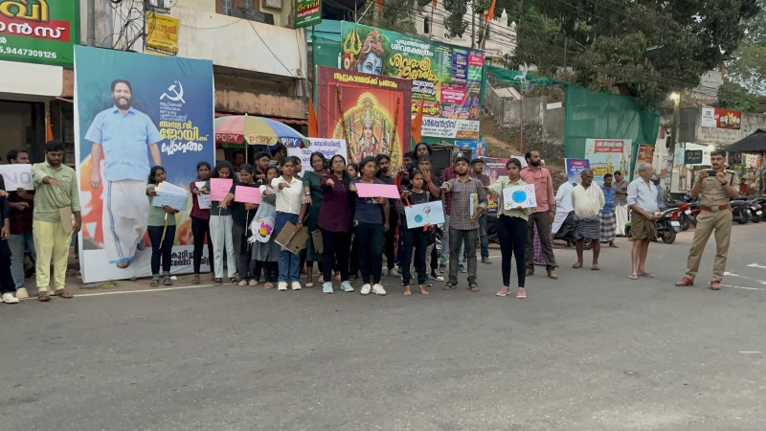

- Railway Station Cleanliness Drive
The NSS unit of Lourdes Matha College of Science and Technology organized a railway station cleaning drive at Thampanoor Railway Station, Thiruvananthapuram, as part of the community service initiative. The event took place on March 2024, with the active participation of NSS volunteers.
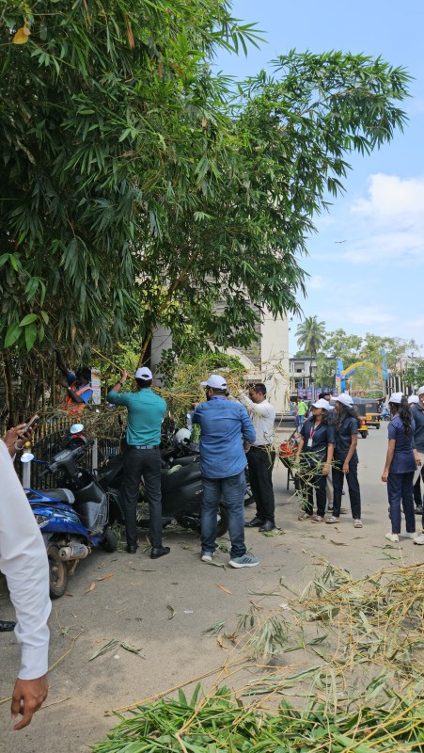
- Swachhatha Hi Seva- Campus Cleaning
As part of the nationwide Swachhata Hi Seva campaign, the NSS Unit of Lourdes Matha College of Science and Technology organized a campus cleaning drive on October 2, 2023. The event was aimed at promoting cleanliness, raising awareness about waste management, and encouraging students and staff to actively participate in maintaining a clean and hygienic environment.
